North Lincolnshire Council
Daily Event Analysis
13th January 2011

Overview

The Dawes Lane Coke Oven (DLCO) Osiris measured a daily mean PM₁₀ concentration of 52µg/m³ on Thursday 13th January 2011 exceeding the allowed 50µg/m³ as a daily mean. The Low Santon TEOM measured a daily mean concentration of 35µg/m³.

A check of the data has revealed elevated concentrations of PM₁₀ between 07:00 and 08:00 at the DLCO Osiris. During this period the DLCO Osiris measured a mean concentration of 170µg/m³ and the Low Santon TEOM 53µg/m³.
Met Conditions

Consistent South Westerly winds were recorded throughout the day. The wind within the 1 hour period of focus ranged between 196° and 221°. Wind speeds averaged at 2 m/s for the day. No rain was measured between 09:00 and 17:00.

Episode Wind Range
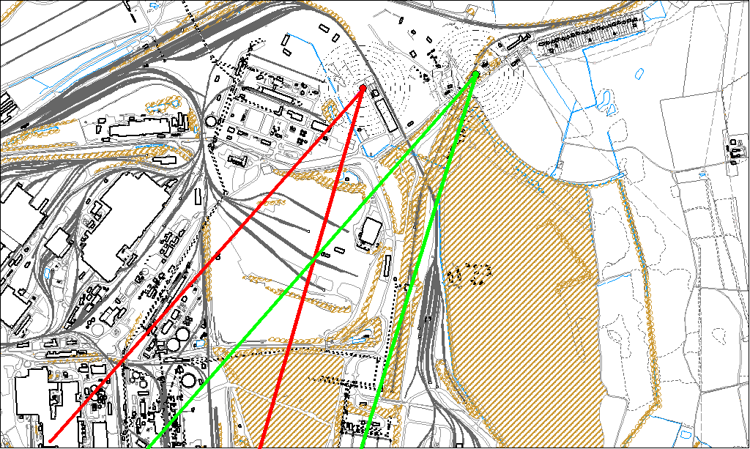

Potential Sources

The above map shows the DLCO Osiris (indicated by the red lines) and the Low Santon TEOM (indicated by the green). As only the DLCO Osiris measured consistently higher concentrations during this period, it is likely that they were affected by a different source. Therefore, the area within the red lines is likely to contain the source.

The likely areas include;
- Redbourn Site
- Appleby Coke Ovens
- Blast furnaces

